What do you do with your customers?

* Onboarding and Implementation
* Needs Assessment and Solution Alignment: I conducted regular check-ins with customers to understand their evolving goals, challenges, and pain points.
* Strategic Planning:
* Proactive Support and Issue Resolution:
* Product Education and Training:
* Performance Analysis and Reporting:
* Feedback Collection and Advocacy
* Renewals and Expansion:
* Relationship Building:

**How you solve customer problem :**

Active Listening: I initiated a call with the client to understand the issue firsthand. I actively listened to their concerns, asked clarifying questions, and empathized with their frustration.

Immediate Action: Understanding the urgency, I immediately involved our technical support team to investigate the root cause of the problem/if needed

Regular Updates: While the technical team was investigating, I maintained regular communication with the client. I provided updates on the progress of the investigation, demonstrating transparency and keeping them informed.

Solution Implementation: Once the root cause was identified, I collaborated with the technical team to develop a solution. I communicated the solution to the client in clear and non-technical terms, ensuring they understood the steps that would be taken.

After implementing the solution, I followed up with the client to ensure that the issue was fully resolved and that their workflow was back to normal. I also offered to assist with any testing or adjustments they needed.

I gathered feedback from the client about their experience. I took note of their suggestions for improvement and shared these insights with our product team.

I worked with the product team to implement preventive measures to avoid similar issues for other clients in the future

How do you do on boarding :

Search about the customer

Collect information about the customer (internal - external)

Call him to introduce my self and that I am going to help them and understand their business and the I have the resources that can help them ,

Conduct introduction call

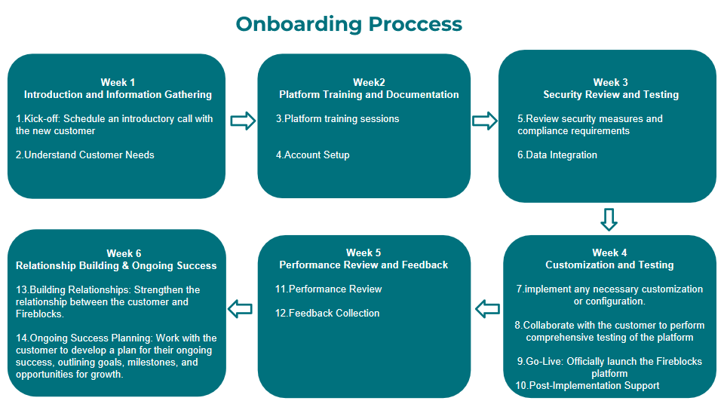

**What is you strategy to do up sell :**

1. Deep Understanding of Customer Needs:

Regularly engage with your customers to understand their current challenges, goals, and long-term plans.

Identify pain points that could be addressed by upselling additional features or services.

2. Tailored Recommendations:

Based on your understanding of the customer's needs, tailor your upsell recommendations to their specific situation.

Highlight how the upsell will address their challenges, improve efficiency, or enable them to achieve their goals more effectively.

3. Showcase Value Proposition:

Clearly communicate the unique value and benefits of the upsell. Focus on how it aligns with the customer's objectives and provides a substantial return on investment.

4. Provide Success Stories:

Share success stories or case studies of other customers who have benefited from the upsell.

Highlight tangible results and outcomes they achieved after adopting the additional features or services.

5. Strategic Timing:

Choose the right moment to introduce the upsell. This could be during regular check-ins, after the customer has achieved a significant milestone, or when discussing their future plans.

6. Demonstrate ROI:

Show the customer how the upsell will directly contribute to their bottom line, whether through increased efficiency, cost savings, or revenue growth.

7. Personalized Pitch:

Craft a personalized pitch that speaks directly to the customer's pain points and aspirations.

Use data and insights from their usage of your current solution to demonstrate how the upsell aligns with their needs.

8. Regular Follow-Up: - After the upsell, continue to monitor the customer's progress and success with the additional features or services. - Address any questions or concerns promptly and provide ongoing support.

**Renewal proccess :**

In general I start the renewal process before 3/4 month from the end date of the contract

From my understanding of their current challenges, goals, and long-term plans.

Identify pain points that could be addressed by upselling additional features or services.

I prepare presentantion , with all the achienvent that we did in the current year and the impcat and the added value that we give to the customer this year ,

Based on my understanding of the customer's needs, I will give new contract plan that alighn with their next projects and workloads , and give upsell recommendations to their specific situation.

Highlight how the upsell will address their challenges, improve efficiency, or enable them to achieve their goals more effectively.

3. Showcase Value Proposition:

Clearly communicate the unique value and benefits of the upsell. Focus on how it aligns with the customer's objectives and provides a substantial return on investment.

After that I prepare proposal and send it to confirm , after that we have negotiation procees about the cost and the services and another view for the proposal answer them about all their questions , till we have confirmation about the proposal from two side , after that it will start the renewal proses based on the customers policies till the customer signature

Sales strategy :

Know your audience

Set goals

How to present you solution and understand what is their benefits from the other solution

Behave as advisor

Sales processes (Prospecting ,Needs Assessment, Presentation and Solution Proposal ,

Address any objections or concerns the prospect may have by providing relevant information and addressing their doubts. , Negotiation and Closing , Closing the Deal)

**managing escalations**

Active listening : When a customer raises an issue or expresses frustration, the first step for a CSM is to actively listen to their concerns.

Assessing הערכה the severity and impact ההשפעה : CSMs evaluate the severity and impact of the escalation by gathering all necessary information. To ask probing questions to understand the specific problem, its impact on the customer's business or experience, and any immediate needs or deadlines involved. This assessment helps determine the appropriate level of urgency and priority for resolution.

Collaborating with support team

communicate transparently with the customer about the escalation process and the expected timeline for resolution. providing regular updates, sharing progress, and being honest about any potential challenges or limitations. Clear communication helps maintain trust and keeps the customer informed throughout the resolution process.

provide updates to the customer, and actively work to drive progress.

CSMs work with the customer to provide interim solutions or workarounds that can mitigate the impact of the issue. This ensures that the customer's business operations can continue while a long-term solution is being developed.

Escalating internally if needed: If the issue remains unresolved or requires further attention, CSMs escalate internally within their organization. This ensures that the escalation receives the necessary attention and resources to reach a resolution.

Once the escalation is resolved, CSMs follow up with the customer to confirm that the issue has been addressed satisfactorily.